Lab - Install the Virtual Machine Lab Environment

# Objectives

1. **Part 1: Prepare a Computer for Virtualization**

**Part 2: Explore the DEVASC VM GUI**

**Part 3: Create Lab Environment Accounts**

**Part 4: Install Webex Teams on your Device**

# Background / Scenario

In this lab, you will install the DEVASC virtual machine (DEVASC VM) in Oracle VirtualBox. After completing the installation, you will explore the GUI interface. You will then create the necessary accounts for the services that you will use throughout the labs. Finally, you will install Webex Teams in the lab environment for communication with the other students in your class, and for use in later labs.

# Required Resources

* Host computer with at least 4 GB of RAM and 15 GB of free disk space
* High-speed internet access to download Oracle VirtualBox and the DEVASC VM

# Instructions

## Prepare a Computer for Virtualization

In this Part, you will download and install desktop virtualization software and the DEVASC VM. Your instructor may provide you with the DEVASC VM file.

**Note**: The following instructions are for Windows 10 using VirtualBox v6.1.4. Your steps may differ slightly. Regardless of the operating system or VirtualBox version, be sure you locate and select the options specified in the following steps.

**Note**: If you have previously installed VirtualBox, you can proceed to Step 2.

### Download and install VirtualBox.

VMware Player and Oracle VirtualBox are two virtualization programs that you can download and install to support the VM images. In this lab, you will use the VirtualBox application.

* + - 1. Navigate to <https://www.virtualbox.org/>. Click the download link on this page.

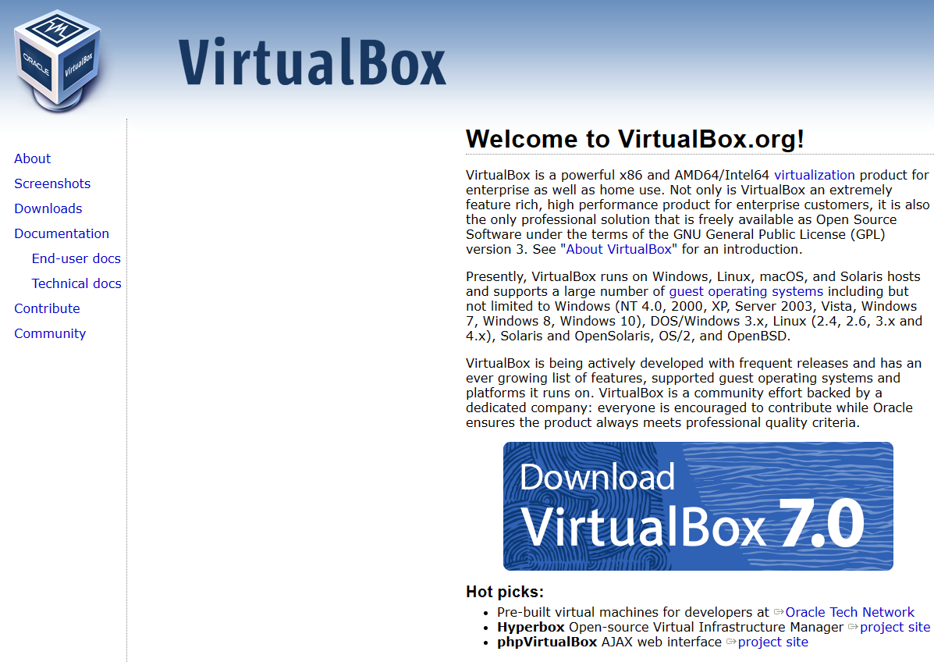

**Figure 1.1 Accessing the link to virtualbox download.**

* + - 1. Choose and download the appropriate VirtualBox installation file based on your operating system.

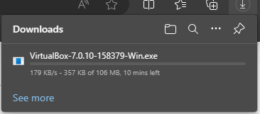

**Figure 1.2 Downloading the appropriate VirtualBox.**

* + - 1. Run the installer for **VirtualBox** and accept the default installation settings.

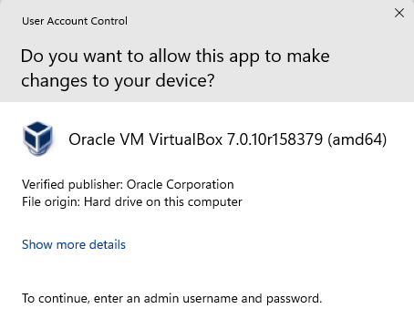

**Figure 1.3 Running the installation after downloading the virtualbox.**

* + - 1. VirtualBox is open and ready for the next step.

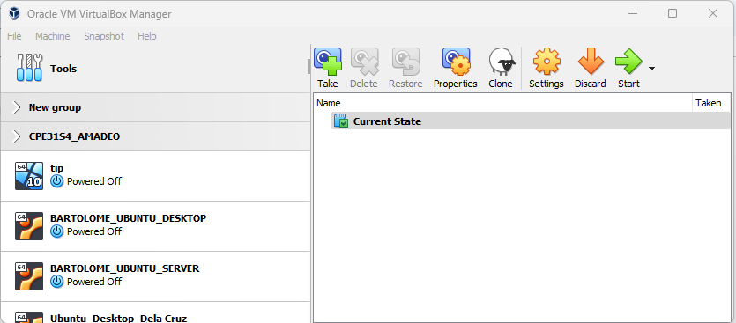

**Figure 1.4 Showing the virtualbox is open and ready for the next step.**

### Import the DEVASC VM.

* + - 1. Navigate to the [Cisco Networking Academy DEVASC VM](https://static-course-assets.s3.amazonaws.com/DEVNET/DEVASC_VM.ova) and download it. Note the location of the downloaded VM.

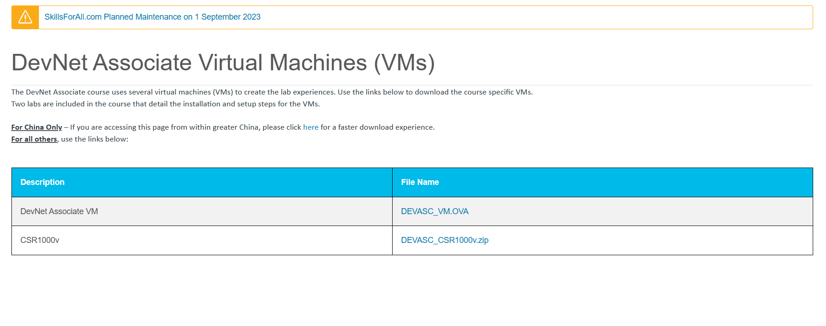

**Figure 2.1 Navigating the link in order to download DEVASC.**

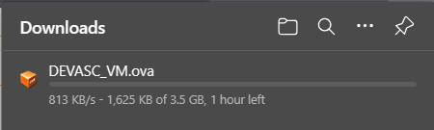

**Figure 2.2 Downloading the DEVASC VM.**



**Figure 2.3 Proof that has already been downloaded.**

* + - 1. In VirtualBox, select **File** > **Import Appliance**.

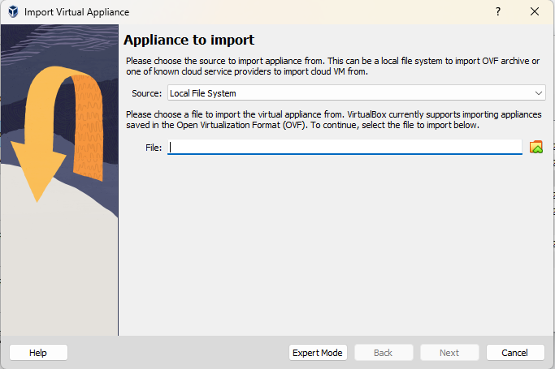

**Figure 2.4 Accessing the import appliance.**

* + - 1. The source of the appliance is **Local File System**. Browse to the location of the downloaded DEVASC VM, and click **Open**.

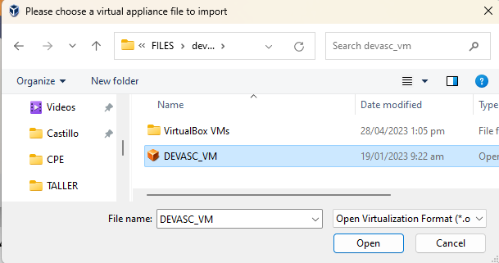

**Figure 2.5 Locating the downloaded DEVASC VM.**

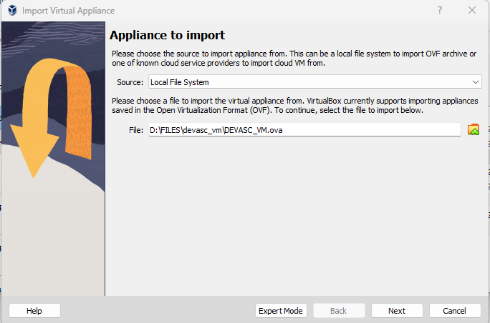

**Figure 2.6 Final output after locating the file DEVASC VM.**

* + - 1. Click **Import** to continue. The import process will take several minutes.

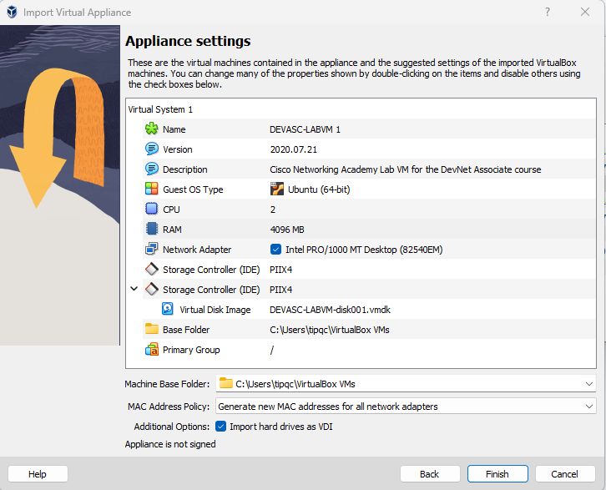

**Figure 2.7 This is the final output after I import the file DEVASC VM.**

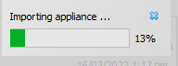

**Figure 2.8 Waiting to finish loading.**



**Figure 2.9 This is the result after I import the DEVASC VM.**

## Explore the DEVASC VM GUI

* + - 1. Start the DEVASC VM. This will take a few minutes as the Ubuntu image boots.
      2. The DEVASC VM contains Packet Tracer. You must agree to the Cisco Packet Tracer EULA to continue starting the VM. When you see the license agreement, use the arrow keys to scroll the text. Press the **Right Arrow** key to select **<OK>** when you are finished. Press the **Space Bar** to move to the Agreement screen. Press the **Left Arrow** key to select **<I Agree>** when you are finished.
      3. The Ubuntu image will continue to load. Close any popup messages.

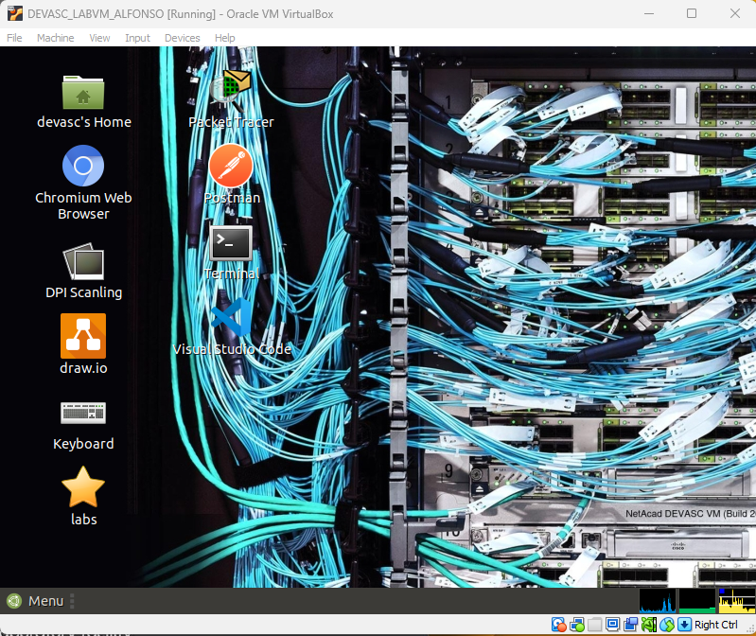

**Figure 3.1 This is the result after I follow the instruction from a - c steps.**

* + - 1. In the later labs, you will use the terminal, VS Code, Packet Tracer, Chromium Browser, and Postman. Open these applications and explore them.

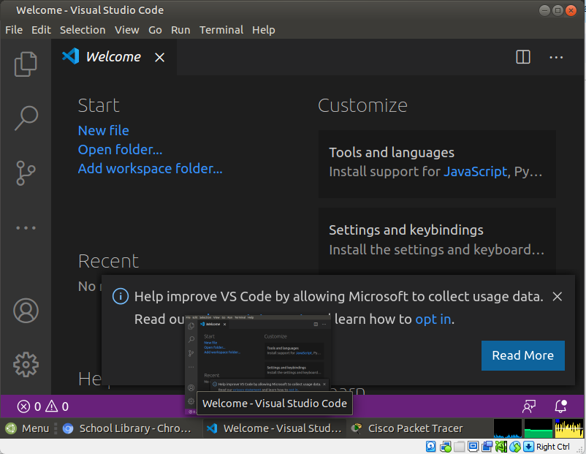

**Figure 3.2 Accessing the VS code on DEVASC VM.**

.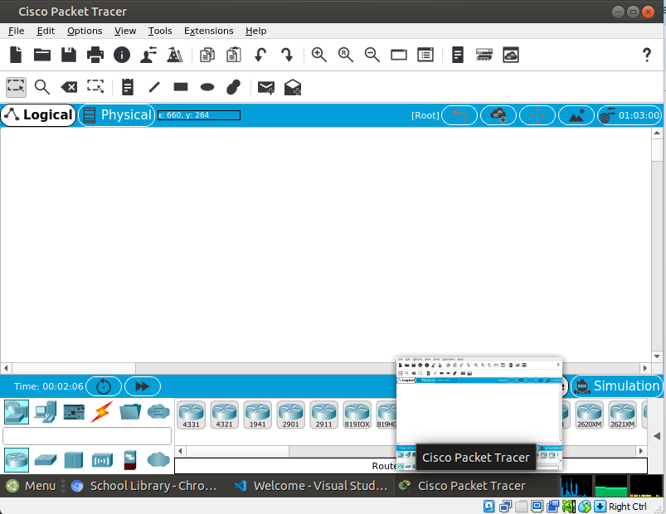

**Figure 3.3 Accessing the Packet Tracer on DEVASC VM.**

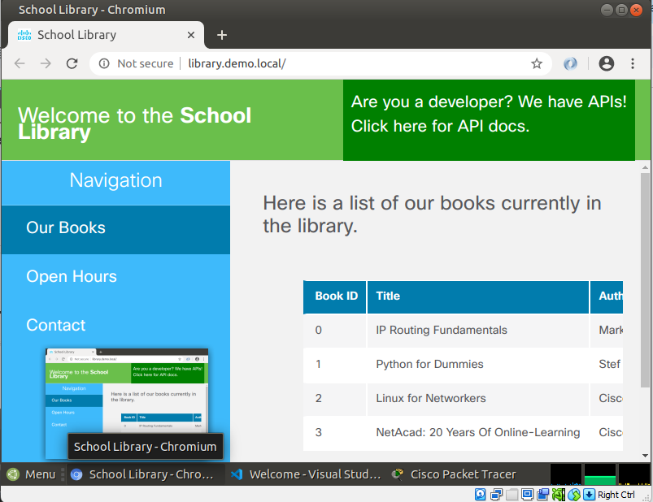

**Figure 3.4 Accessing the Chromium Browser on DEVASC VM.**

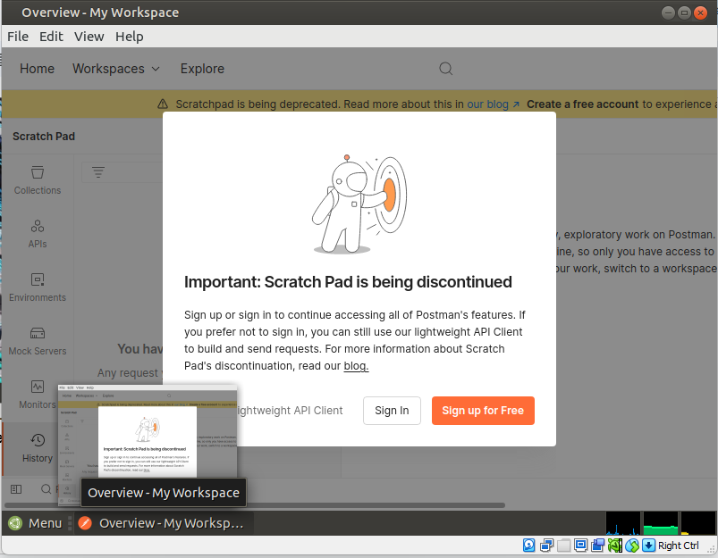

**Figure 3.5 Accessing the Postman on DEVASC VM.**

* + - 1. Click the **Menu** button and explore the **Places**, **System**, and **All applications**.

Remember that this is a virtual machine and is completely separate from the computer on which it is installed. You can make any changes you like. If you make a mistake, or break something, you can simply remove the VM from VirtualBox, and import a fresh copy from the file you downloaded. This is a great way to experiment with programs without affecting your real computer. Don't be afraid to explore and have fun!

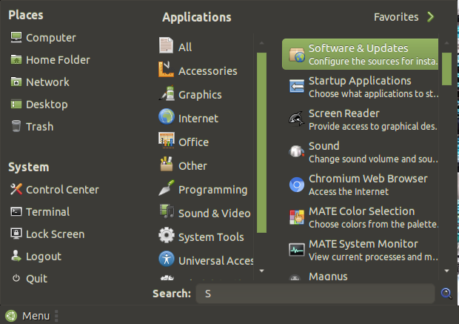

**Figure 3.6 Screenshot of clicking the menu button and explore the Places, System, and All applications.**

## Create Lab Environment Accounts

There are many tools that you will need to use to complete the labs in this course. Some of these require you to have your own account. These are easy to set up and can be done for free. In this Part, you will create the accounts you will need for the rest of the course.

### Create a DevNet account.

* + - 1. Open the Chromium browser and navigate to [developer.cisco.com](https://developer.cisco.com/).

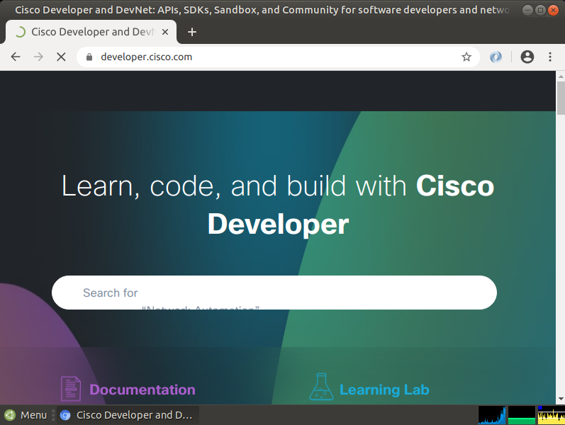

**Figure 4.1 Opening the Chromium browser and navigating the link.**

* + - 1. Click SIGN UP FREE.

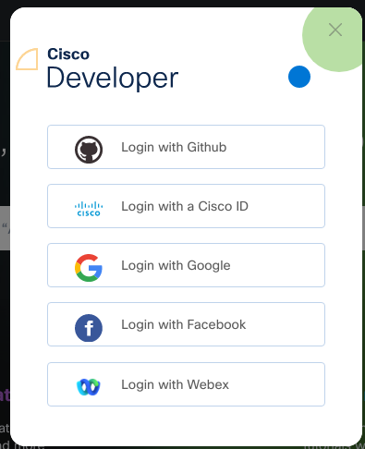

**Figure 4.2 This will show up after clicking sign up free.**

* + - 1. You can choose any of the Login types for which you already have an account. This allows for easy association with other accounts. If you do not wish to associate your DevNet account with any other apps, Choose **Login with a Cisco ID**.
      2. Follow the instructions to complete the account creation.

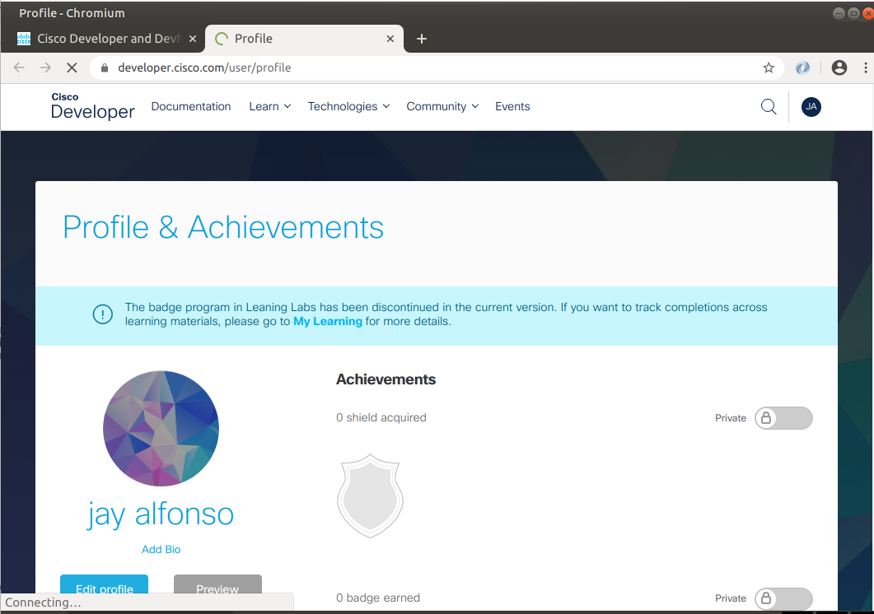

**Figure 4.3 This is the final output after I follow the instructions on c and d.**

### Create a GitHub account.

* + - 1. Navigate to [github.com](https://github.com/).

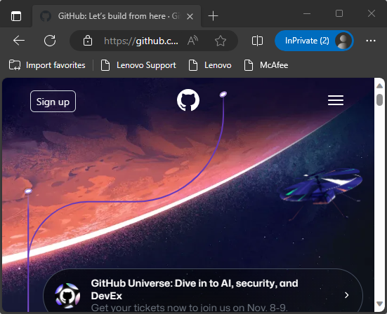

**Figure 5.1 Navigating github.com.**

* + - 1. Fill in the fields for **Username**, **Email**, and **Password**, and then click **Sign up for GitHub**.
      2. Perform any verification to ensure you are human.
      3. Click **Join a free plan**.
      4. On the next page, click **Complete Setup**.

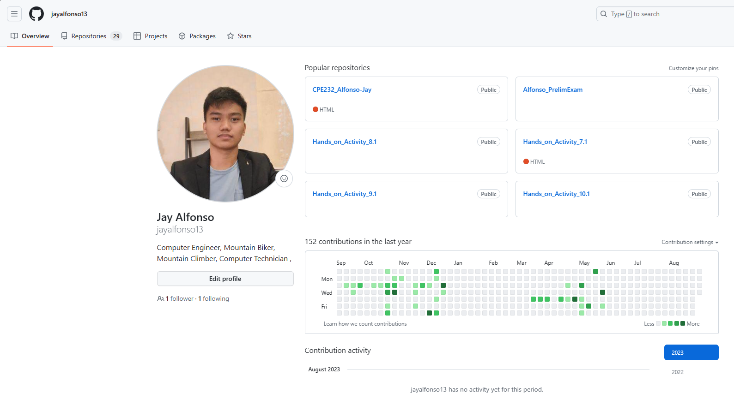

**Figure 5.2 Since i have an existing account, here is my github account.**

### Create a Webex account.

* + - 1. Navigate to [webex.com](https://webex.com).

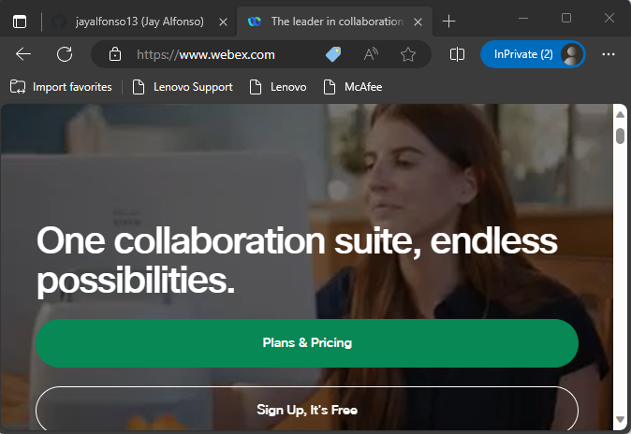

**Figure 6.1 Navigating webex.com.**

* + - 1. Click **Start for Free** or **Sign up now, it's free**.
      2. Enter the **Email address** you wish to use.

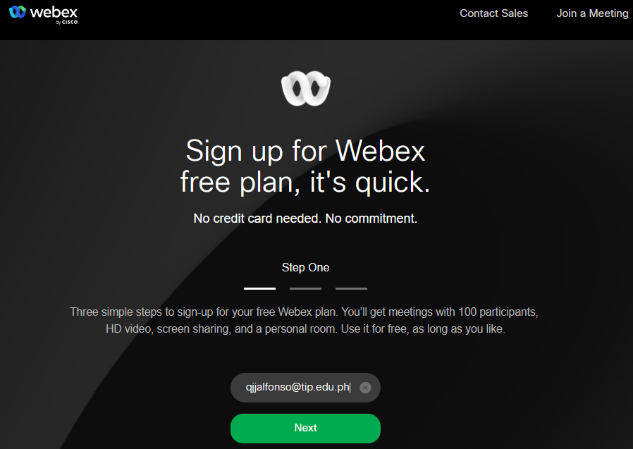

**Figure 6.2 Sign up and enter email address.**

* + - 1. Click **Sign Up**.
      2. Follow the instructions to complete the account creation.

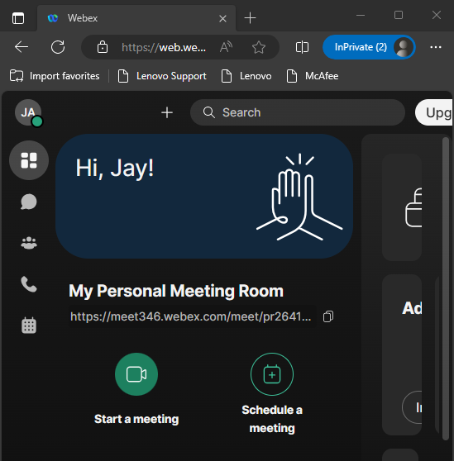

**Figure 6.3 This is the final output after I follow all the instructions.**

### Shut down the VM.

When you are done with the VM, you can save the machine state of the VM for future use or shut down the VM.

**Close the VM using the GUI:**

* + - 1. From the Virtual Box File menu, choose **Close**...

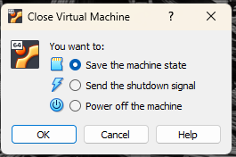

**Figure 7.1 This is the prompt when choosing to close.**

* + - 1. Click the **Save the machine state** radio button and click **OK**. The next time you start the virtual machine, you will be able to resume working in the operating system in its current state.

The other two options are:

* **Send the shutdown signal**: This simulates pressing the power button on a physical computer.
* **Power off the machine**: This simulates pulling the plug on a physical computer.

**Close the VM using the CLI:**

To shut down the VM using the command line, you can use the menu options inside the VM or enter **sudo shutdown -h now** command in a terminal window.

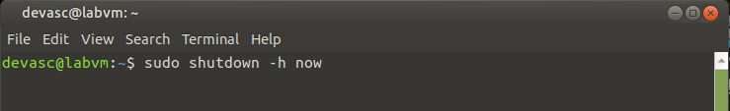

**Figure 7.2 This is the terminal command will shutdown.**

**Rebooting the VM:**

If you want to reboot the VM, you can use the menu options inside the VM or enter the **sudo reboot** command in a terminal.

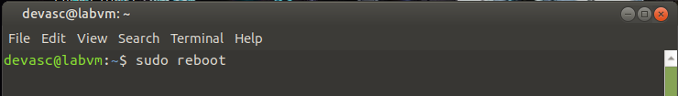

**Figure 7.3 This is the terminal command will reboot.**

## Install Webex Teams on your Device

In this Part, you will install Webex Teams

### Download the installation file.

* + - 1. Navigate to [www.webex.com/downloads.html](https://www.webex.com/downloads.html)

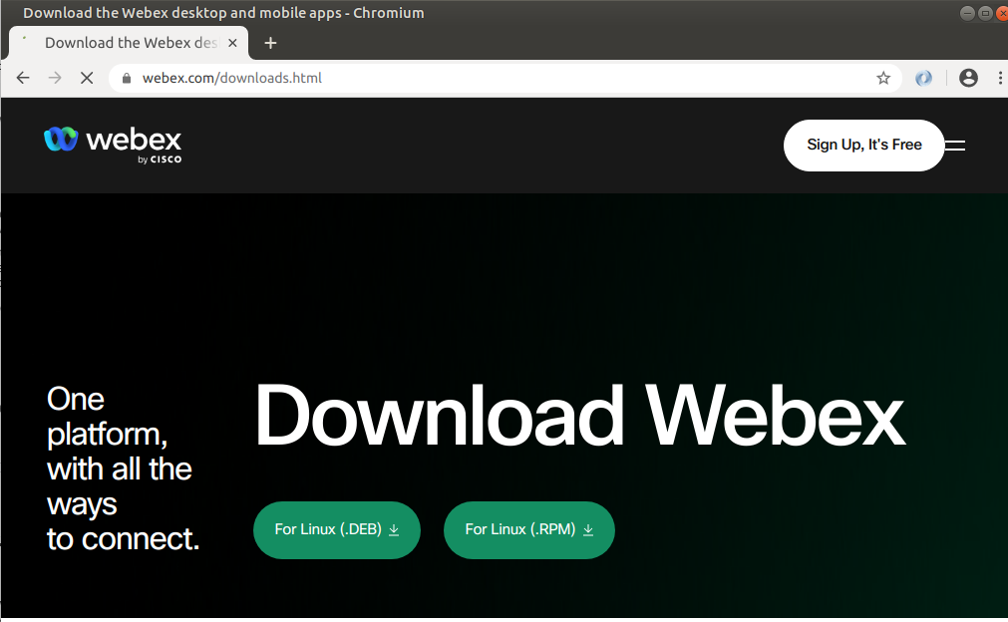

**Figure 8.1 Navigating the www.webex.com/downloads.html.**

* + - 1. Under **Webex Teams**, click **Download for Windows**, or you can choose to install Teams on your mobile device.

**Note**: For MacOS, you will download the Mac version. At the time of this lab was written, there is no Linux desktop application. However, you can run Webex Teams in a browser. Click **Sign in** at the top and choose **Webex Teams**. Then sign in with your new Webex account credentials.

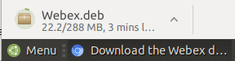

**Figure 8.2 Downloading the Webex.DEB.**

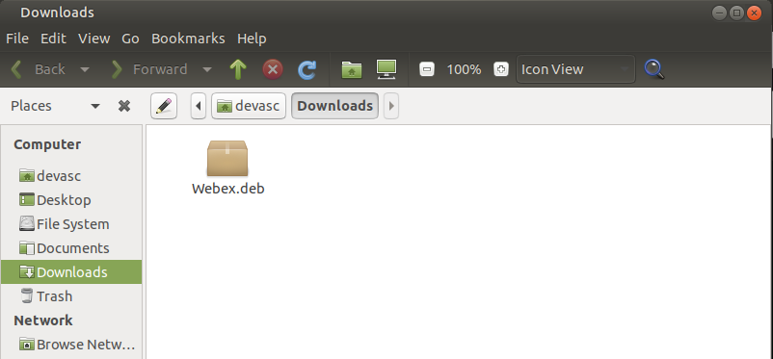

**Figure 8.3 This is the finished downloaded Webex.DEB file.**

* + - 1. Open the installation file and follow the instructions to finish the installation.

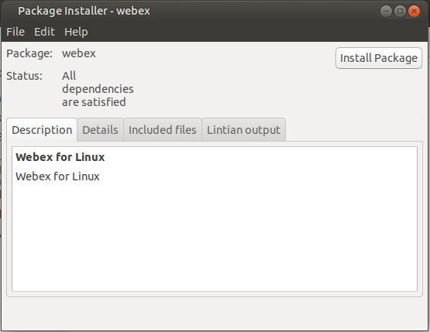

**Figure 8.4 This installation process didn’t work for me.**

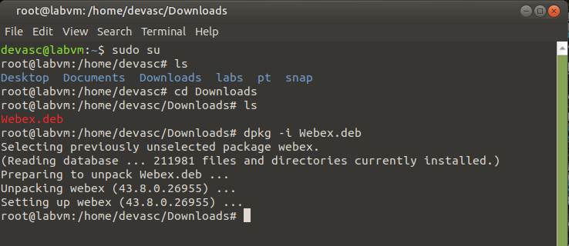

**Figure 8.5 Using the terminal I install the webex.deb through the terminal since it needs the authentication.**

### Launch Webex Teams.

Open Webex Teams. If your instructor already created a Team, you should see that you are now a member. If not, then you can do one of the following:

* Give your instructor your email address so that you can be added to the class Team.
* Create your own Team. In the left panel, click the **Teams** button. Then click the plus button to Create a team. A Team is required for the next step.

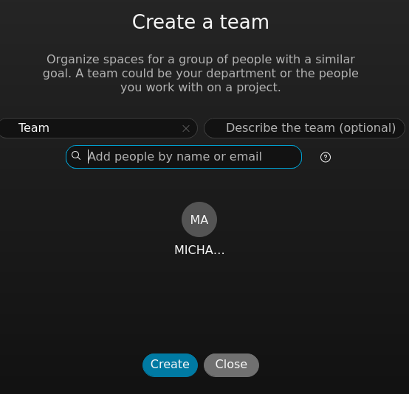

**Figure 9.1 Open the Webex Teams.**

### Add a user to Webex Teams.

* + - 1. In Webex Teams, search for a user in the **Search** field. You may search by username or email. The user must be a member of your team.

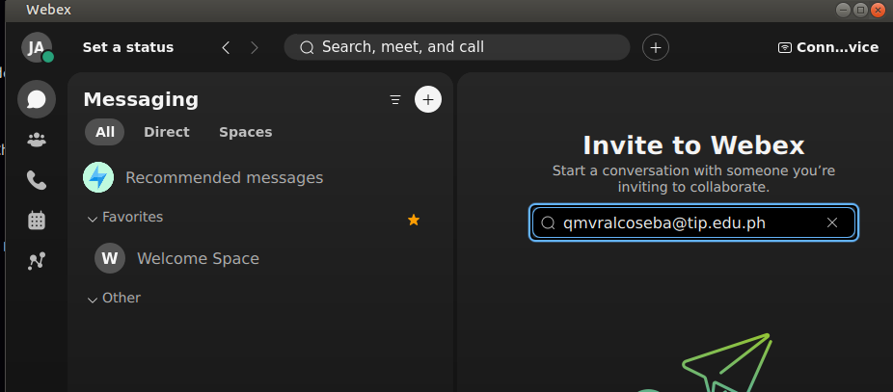

**Figure 10.1 Searching for a user in the search field.**

* + - 1. Click the user in the list of search results to open a **space**.

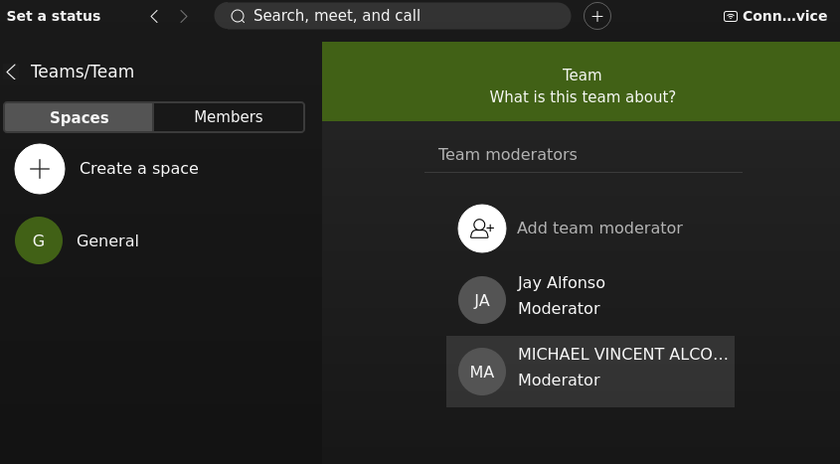

**Figure 10.2 Clicking user in the list of search results.**

* + - 1. Type a message to the user. They will be notified of your message and can now return a message to you.

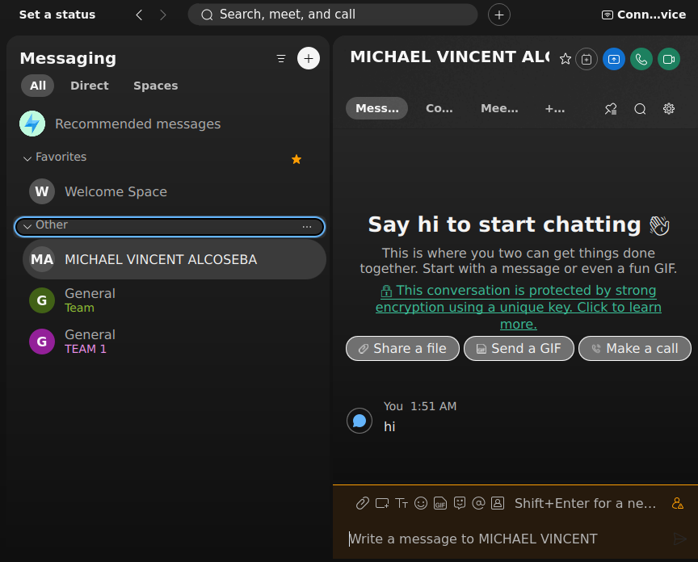

**Figure 10.3 Messaging to the user.**

In conclusion, this lab focused on the installation and setup of the DEVASC virtual machine using Oracle VirtualBox. The multi-part process began with preparing the computer for virtualization, followed by an exploration of the DEVASC VM's GUI. It established the essential accounts required for accessing various services integral to the lab exercises. The final step involved installing Webex Teams within the lab environment, facilitating seamless communication among peers and enabling collaborative engagement. Through these tasks, participants not only gained hands-on experience with virtualization and software installation but also set the stage for productive interactions and learning experiences throughout the course.

*End of document*